API Quota Management System

Advanced Database Systems (MongoDB)

Overview

Tasks
- Design collections and insert sample data.
- Implement CRUD operations for core entities.
- Write filter and sort queries for operational reporting.
- Build aggregation pipelines for analytics.

Group Members
BCSF24M007 | Maaz Bin Asif
BCSF24M033 | Syed Ahmad Raza
BCSF24M021 | Hafiz Abdul Rahman

7 May 2026
Table of Contents
Overview 1
Tasks 1
Group Members 1
Project Introduction 3
Key Features 3
Technology Stack 3
Directory and File Functions 4
Data Model 5
Query Modules 5
5.1 CRUD Scripts (Queries/CRUD/) 5
developer.js 5
quota_plans.js 5
api_key.js 6
usage_bucket.js 6
overage_event.js 6
audit_log.js 6
5.2 Filter and Sort (filter_and_sort.js) 6
5.3 Aggregation (aggregation.js) 7

Project Introduction
This project implements an API quota and rate limiting system using MongoDB. It includes a complete data model plus a set of scripts that you can run directly in mongosh to enforce quotas, track usage, handle overages, and maintain full audit traceability.

Key Features
- Strict schema validation for developers, API keys, and quota plans.
- Time-bucketed usage counters for per minute, per-hour, and per-day windows.
- Overage handling, including throttling, warnings, and key revocation, recorded as events.
- Audit trail for operational and security actions in a dedicated audit_logs collection.
- Realistic sample dataset with 25 developers across 4 plan tiers, including active and revoked keys.
Deliverable: Ready-to-run mongosh examples covering CRUD, filter/sort reporting, and aggregation analytics.

Technology Stack
Component | Technology
Database | MongoDB
Shell | mongosh
Language | JavaScript (supported by mongoDB)
Validation | MongoDB JSON Schema

Directory Structure
api_rate_limit_quota_db
|-- COMPLETE.js
|-- readme.md
|-- Queries/
| |-- aggregation.js
| |-- filter_and_sort.js
| \-- CRUD/
| |-- api_key.js
| |-- audit_log.js
| |-- developer.js
| |-- overage_event.js
| |-- quota_plans.js
| \-- usage_bucket.js
| usage_bucket.js
|-- sample_data/
| |-- api_keys.js
| |-- audit_logs.js
| |-- developers.js
| |-- overage_events.js
| |-- quota_plans.js
| \-- usage_bucket.js
\-- schema/
|-- api_keys.js
|-- audit_logs.js
|-- developers.js
|-- overage_events.js
|-- quota_plans.js
|-- usage_buckets.js
\-- schema.md
overage_events.js
quota_plans.js
schema.md
usage_buckets.js

Directory and File Functions
Directory / File | Function
schema/ | Contains one JavaScript file per collection, each defining a MongoDB JSON Schema validator.
schema/schema.md | Documentation of every field constraint and enumeration for all six collections.
sample_data/ | Seed scripts that insert realistic documents into each collection.

Directory / File | Function
Queries/CRUD/ | CRUD scripts (create, read, update, delete) for each collection, using valid cross-collection references.
Queries/filter_and_sort.js | Examples such as recently onboarded developers, active keys by plan, top daily usage buckets, and recent enforcement actions.
Queries/aggregation.js | Aggregation pipelines (e.g., top developers by today’s usage and active-key plan distribution).
COMPLETE.js (root) | Global script. Loads and executes schema/, sample_data/, and Queries/ files in order.

Data Model
Collection | Purpose
developers | Represents API consumers — individuals or teams. Stores identity, organisation, and account status.
quota_plans | Named plan tiers (Free, Basic, Pro, Enterprise) with rate-limit rules such as requestsPerMinute, requestsPerHour, and requestsPerDay.
api_keys | Credentials issued to developers. Linked to a developer and a plan. Tracks active/revoked state and timestamps.
usage_buckets | Time-windowed request counters per API key. Supports minute, hour, and day period types to enable rolling-window enforcement.
overage_events | Records each policy violation: which key exceeded which limit, by how much, and what enforcement action was taken.
audit_logs | Append-only operational and security log. Captures actor (admin/system/developer), action, target entity, timestamp, and relevant metadata.

How to run
$hell> mongosh COMPLETE.js

Query Screenshots
CRUD for usage_bucket, overage_event, api_key
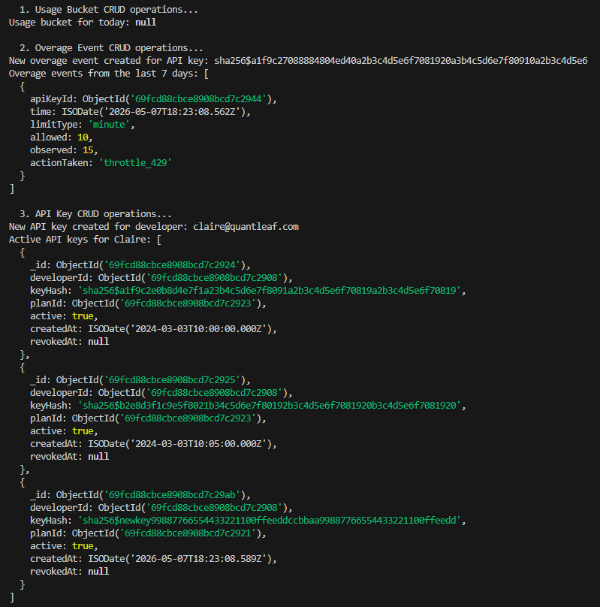

Quota_plans and Developers
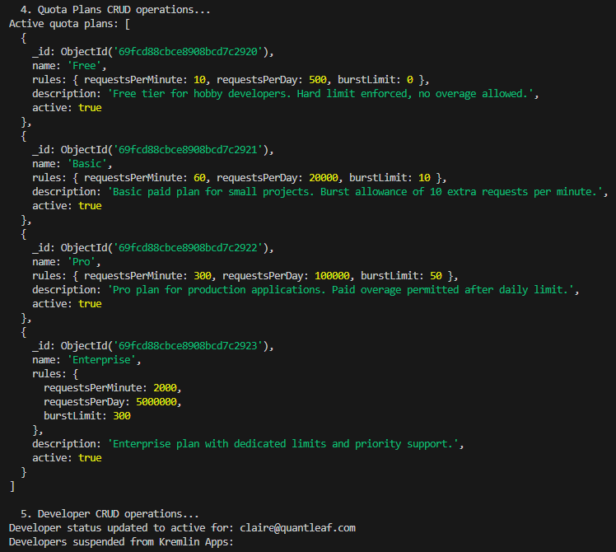

Filtering Api Keys
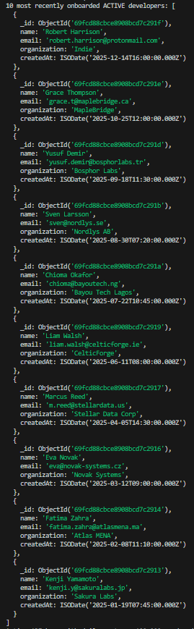
Api Keys with Quota
